This guide helps you get started with using the product, guiding you through the installation process, what features the product has, how it functions and how to use it properly.

**Package Content**

Your product should have all the components shown in table 6.1. Ensure that you have received all the components, else contact the FYP team if something is missing.

|  |  |
| --- | --- |
| Components | Details |
|  | White Box |
| Digital Infrared Temperature Sensor – MLX90614 / MLX-90614 / MLX 90614: Buy  Online at Best Prices in Pakistan | Daraz.pk | Contactless Temperature Sensor (MLX90614)  Located on top of the white box |
| Heart rate sensor module MAX30102 - pulse sensor | SpO2 Sensor (MAX30102)  Located on top of the white box |
| HC SR04 HC-SR04 Arduino Ultrasonic Sensor | Sonar Sensor  Located on top of the white box |
| Logitech C505 720p HD WebCam with 720p and Long-Range Mic Pakistan | Logi 720p USB Camera |
| FHD 1080P MF Webcam(PK-935HL) | | Atech 1080p Manual Focus USB Camera |
| C:\Users\HP\Desktop\FYP Final Documents\extra\WhatsApp Image 2022-06-20 at 8.31.31 PM.jpegC:\Users\HP\Desktop\FYP Final Documents\extra\WhatsApp Image 2022-06-20 at 8.31.31 PM.jpeg | Dual Mini-Speaker |
| 5V Electric Door Lock Solenoid Lock in Pakistan - Electronics Pro | 5V DC Electric Door Lock |
| Computer monitor - Wikipedia | Monitor |
| 5V 3A Power ADAPTER CHARGER for RASPBERRY PI 3 Micro USB buy in Pakistan | 5V 3A Power Supply Adaptor |
| Hdmi To Vga Converter With Sound- White: Buy Online at Best Prices in  Pakistan | Daraz.pk | VGA to HDMI Convertor |

Table 6.1

**Product Features**

This product has the following features included:

1. Single person face mask detection using Logi 720p USB Camera with 25 FPS and displays the result on the monitor attached.
2. Single person contactless body temperature sensing using MLX90614 Sensor and displays the result on the monitor attached.
3. Single person oxygen saturation in the bloodstream (SpO2) sensing using MAX30102 sensor which requires index finger to be pressed firmly on it and displays the result on the monitor attached.
4. Social distancing detection among the first 3 people in the single file queue using Atech 1080p Manual Focus USB Camera with 20 FPS and displays result on the monitor.
5. Audio assistance that guides the user throughout the entire process using dual mini-speakers in English and generates warning when required.
6. Automatic door locking and unlocking mechanism using a 5V DC electronic door lock that unlocks the door for 5 seconds.
7. Compact and portable product body, colored opaque white hiding all the inner connections.
8. A 12V DC Fan that keeps the internal system of the product cool.
9. A Monitor for display of all results.

**Top View of Product**

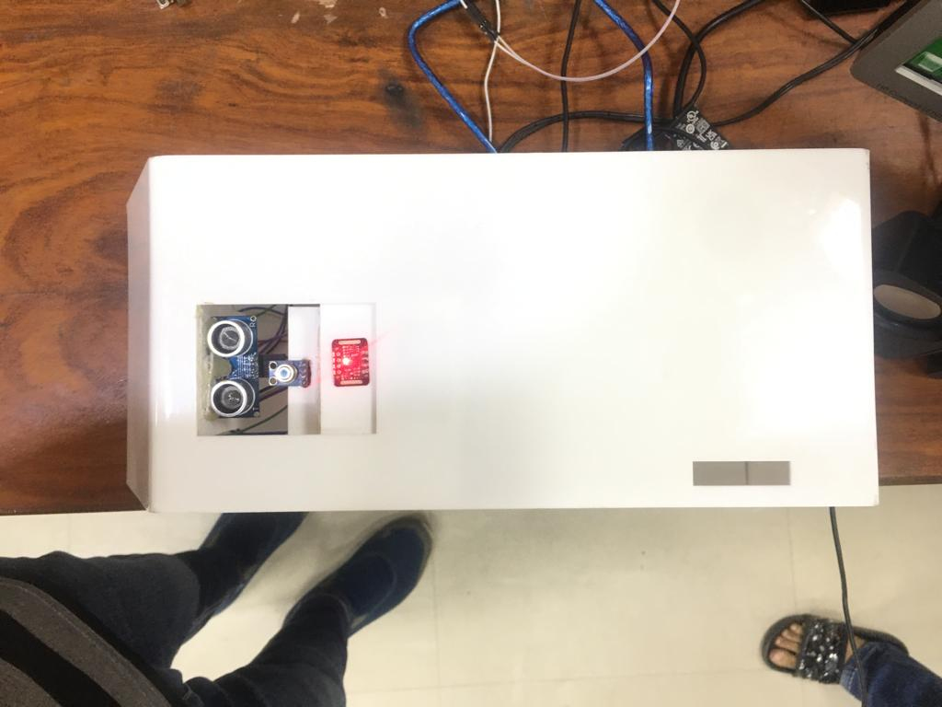

Fig 6.1

**Complete Product**

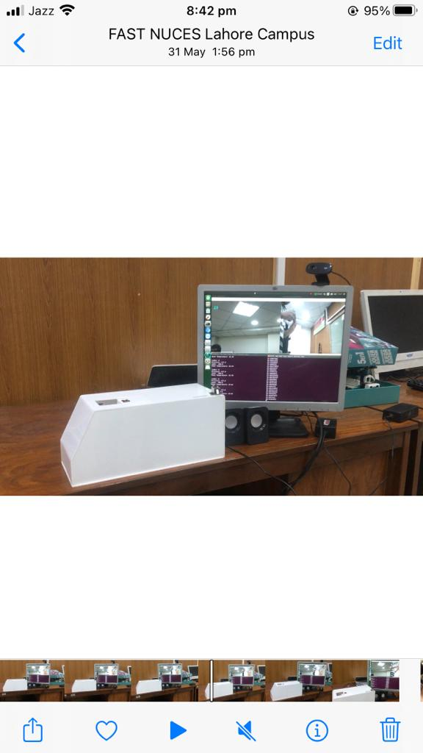

Fig 6.2

**Setting Up the Product**

**Note:** In case of any difficulty contact the FYP team or if you want us to install it for you.

**Note:** Make sure that there is some backup power in case of a power shortage. Connect first, then turn on the power.

1. **Setting the Logi Camera**

Using a screw driver, attach the logi camera (see table 6.1) at the face level of a person where the queue is going to start.

1. **Setting the Atech Camera**

Using a screw driver, attach Atech Camera (see table 6.1) perpendicular to the start of the queue, where three persons are visible in the camera frame.

1. **Setting Dual mini-speakers**

Insert the pin of the speakers inside the port of the VGA to HDMI convertor (see table 6.1). Place these speakers near the white body of the product.

1. **Setting the Monitor**

Place the monitor near the white body of the product, facing towards the queue, so that the first person could properly see what the results are.

1. **Setting the Product White Body**

The white body of the product is to be set at a minimum height of 4 feet from the ground using the stand. This should be placed at the side of the queue and at the starting of the queue.

In order to get everything in working condition, follow the given steps.

1. Connect Atech Camera (see table 6.1) with USB port.
2. Connect Logi Camera (see table 6.1) with USB port.
3. Connect the 5V 3A power adaptor with the USB micro port. Plug this adaptor with any outlet.
4. Connect the blue wire (see table 6.1) with USB port.
5. Connect HDMI cable with HDMI port.
6. Plug the 12V power adaptor (see table 6.1) with any outlet.

**Operating the Product**

1. Turn on the power supply for the 5V and 12V power adaptor (see table 6.1) and wait for the system to boot up. The desktop should be displayed on the monitor.
2. After booting up the system, open complete FYP folder on the desktop. There should be 3 .py files and 6 other documents.
3. Right click on the folder. A drop-down menu should be opened in which click of Open in Terminal.
4. Repeat step 3 times.
5. Three black windows should open (aka terminals). Write python3 a.py in one terminal, python3 q.py in the second terminal, and python3 ard.py in the third terminal. This would activate the cameras and start the process.

**Note: No file should be opened or modified, else the product might not work as the source files are tempered with.**

1. When the product is to be turned off, close all the terminals and folders, and click on shut down button from the top right corner. After the system is shut down, turn off the power supplies and unplug the adapters.

**Note: Beyond this point, no human interaction is required since this product is fully automated.**

**About the Product Functionalities**

Once the system is boot up and files are executed in the terminals, the product starts checking the SOPs of COVID-19 onto the first person in the queue.

The speaker would start speaking ‘**Please place your hand on sensor**’ until a hand is placed on top of the sensors.

The index finger should be firmed pressed onto the SpO2 sensor (see table 6.1) and the rest of the hand should hover over the contactless temperature sensor (see table 6.1).

The face of the first person should look at the Logi Camera installed at the front of the queue.

The Atech camera installed at the side of the queue would be automatically checking the distance between the first three individuals in the queue.

If all SOPs (face mask, body temperature, SpO2, and social distancing) are being followed, the system would speak “**Opening door, please move along**” and then “**Your temperature is 34˚C**”. The door would be unlocked for 5 seconds after which it would automatically lock itself.

If face mask violation is detected, the system would say “**You are not wearing facemask**” and would not open the door and stop saying that until that person wears a facemask or gets out of the queue.

If temperature is abnormal, the system would say “**You have high temperature**” and if SpO2 reading is low, the system would say “**SpO2 is inadequate**”.

If social distancing is violated, then the system would say “**Social distancing violation**”.

**Maintenance Guidelines**

For best practices, follow the instructions in the list below while unpacking, cleaning, or handling your product:

* Keep the product away from direct sunlight to avoid any heating problems or short circuit.
* Do not temper with the internal wiring, or the cables as it might cause the system to go faulty.
* Keep the system away from water to avoid short circuit. Inorder to clean the product, make sure to use a lightly damped cloth with water.
* Do not run the system for more than 10 hours to prevent any permanent damages to the system.
* When turning off the system, do not directly turn off from the power supply as this causes damages to the memory card of the system.

**Troubleshooting**

* **System not booting**

Turn off and then turn on the system from the outlet a few times. This indicates that the memory card might be corrupted due to power shortage and can be fixed by contacting the FYP team.

* **System is booted but no display on Monitor**

Check the VGA to HDMI cable and make sure the VGA plug is properly connected from both sides, the monitor and the convertor cable.

Check if the power plug of the monitor is properly connected.

Verify if the VGA cable is not faulty. Test the system with another VGA cable.

* **Camera results swapped**

If Logi camera is being used for social distancing and Atech camera is being used for face mask detection, then it is possible that the connections are not done properly. Connect Atech Camera with USB port 2 and connect Logi Camera with USB port 1.

* **SpO2 sensing is not working**

It is preferred that the user should place their index finger for more accurate reading. The index finger should be firmly pressed and not be moving. It takes 5 seconds for the SpO2 value to be shown on the monitor so keep the index finger pressed till then.

**Note: In case of any other issues with the system, contact the FYP team.**